Exp-7
package servletDemo;
import java.net.*;

public class InetDemo {
public static void main(String[] args) {
try {
InetAddress local = InetAddress.getLocalHost();
System.out.println("Local Host:");
System.out.println("Host Name: " + local.getHostName());
System.out.println("IP Address: " + local.getHostAddress());
InetAddress google = InetAddress.getByName("www.google.com");
System.out.println("\nUsing getByName():");
System.out.println("Host Name: " + google.getHostName());
System.out.println("IP Address: " + google.getHostAddress());
InetAddress[] addresses = InetAddress.getAllByName("www.google.com");
System.out.println("\nUsing getAllByName():");
for (InetAddress addr : addresses) {
System.out.println(addr);
}
byte[] ip = {8, 8, 8, 8};
InetAddress addr = InetAddress.getByAddress(ip);
System.out.println("\nUsing getByAddress():");
System.out.println(addr);
} catch (Exception e) {
System.out.println(e);
}
}
}

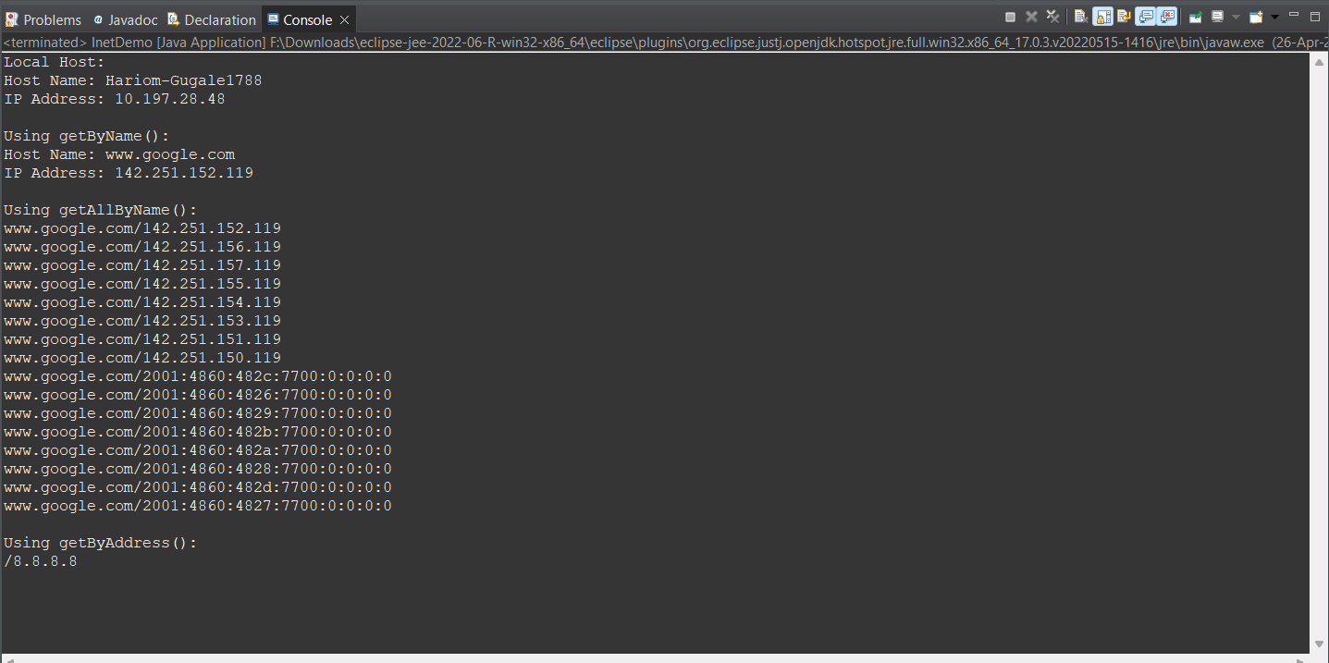

Exp-8A
LoginServlet.java

package servletDemo;

import java.io.*;
import javax.servlet.*;
import javax.servlet.http.*;
import javax.servlet.annotation.WebServlet;

@WebServlet("/login")

public class LoginServlet extends HttpServlet {

protected void doPost(HttpServletRequest request, HttpServletResponse response)
throws ServletException, IOException {
response.setContentType("text/html");
PrintWriter out = response.getWriter();
// Get form data
String username = request.getParameter("username");
String password = request.getParameter("password");
// Simple authentication (hardcoded)
if(username.equals("Hariom") && password.equals("1234")) {
out.println("<h2>Login Successful!</h2>");
out.println("<h3>Welcome " + username + "</h3>");
} else {
out.println("<h2>Invalid Username or Password</h2>");
}
}
}
Login.html
<!DOCTYPE html>
<html>
<head>
<title>Login Form</title>
</head>
<body>

<h2>Login Form</h2>

<form action="login" method="post">
Username: <input type="text" name="username"><br><br>
Password: <input type="password" name="password"><br><br>
<input type="submit" value="Login">
</form>

</body>
</html>

Output

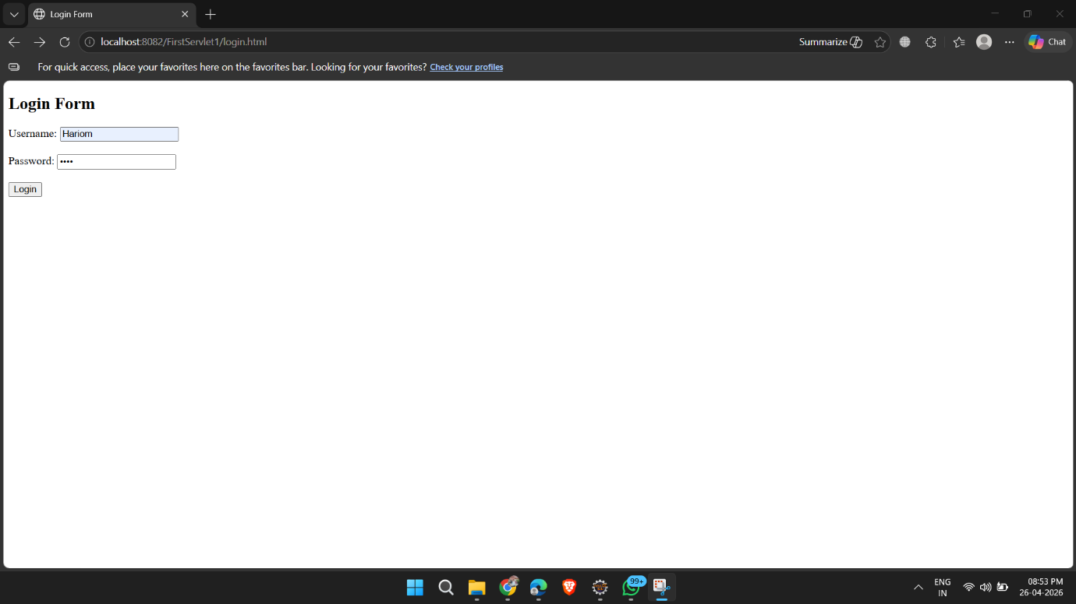

Exp-8B
CalculatorServlet.java
package servletDemo;

import java.io.*;
import javax.servlet.*;
import javax.servlet.http.*;
import javax.servlet.annotation.WebServlet;

@WebServlet("/calc")

public class CalculatorServlet extends HttpServlet {

protected void doPost(HttpServletRequest request, HttpServletResponse response)
throws ServletException, IOException {

response.setContentType("text/html");
PrintWriter out = response.getWriter();

double num1 = Double.parseDouble(request.getParameter("num1"));
double num2 = Double.parseDouble(request.getParameter("num2"));

String operation = request.getParameter("operation");
double result = 0;

if(operation.equals("Add")) {
result = num1 + num2;
}
else if(operation.equals("Subtract")) {
result = num1 - num2;
}
else if(operation.equals("Multiply")) {
result = num1 * num2;
}
else if(operation.equals("Divide")) {
if(num2 != 0)
result = num1 / num2;
else {
out.println("<h3>Cannot divide by zero</h3>");
return;
}
}

out.println("<h2>Result = " + result + "</h2>");
}
}

Calculator.html
<!DOCTYPE html>
<html>
<head>
<title>Simple Calculator</title>
</head>
<body>

<h2>Simple Calculator</h2>

<form action="calc" method="post">
Enter Number 1: <input type="text" name="num1"><br><br>
Enter Number 2: <input type="text" name="num2"><br><br>

<input type="submit" name="operation" value="Add">
<input type="submit" name="operation" value="Subtract">
<input type="submit" name="operation" value="Multiply">
<input type="submit" name="operation" value="Divide">

</form>

</body>
</html>

Output
